Curriculum vitae

Personal details:

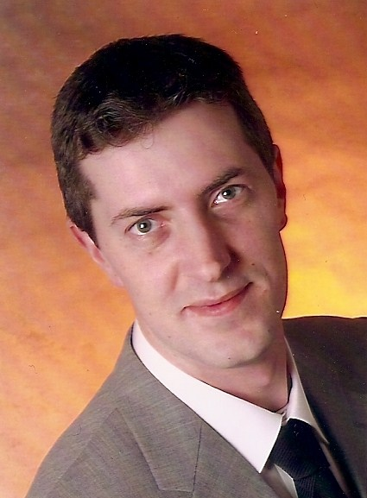

Name: Marko Labudda
Birthday: March, the 9th 1975
Place of birth: Bremerhaven
Nationality: german
Marital status: single

Professional experience

07. 2005 – today emloyed as process engineer & manufacturing engineer on behalf of Airbus Deutschland GmbH in Seville/Spain
Tasks:
- coordination (production, construction, IFA-Bremen & ac-magement) in the final assembly line in Seville
- controll of workorders,
- . . . . .

Professional educations and further educations

07. 1991 – 07. 1993 . . . . .

Seminares

Nov. 1998 . . . . .

School leaving qualification Technological-Highschool-Qualification
at

Languages good German and English in word and document

Computer-skills MS-Office Professional

